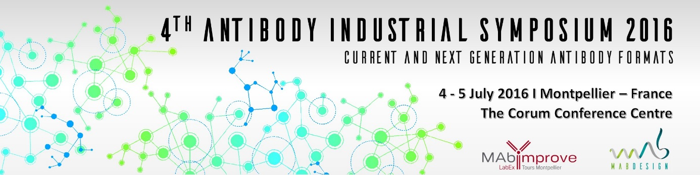

4th Antibody Industrial Symposium 2016
4-5 July 2016, Montpellier
Session “New Antibody Formats and Technology”
Abstract Form

Speaker personal details
First Name: Last Name:
Company/Organization:
Affiliation/Department:
Job Title(s):
Address:
Zip/Postcode: City:
Country:
Telephone (include country code): Mobile (include country code):
E-mail:
Biography (maximum 100 words):

ABSTRACT

Title:
Author(s):

Author’s affiliation:

Abstract (maximum 500 words):

Keywords (provide 5 words):

